THE UNIVERSITY OF THE WEST INDIES

The Office of the Board for Undergraduate Studies

# INDIVIDUAL PLAGIARISM DECLARATION

This declaration is being made in accordance with the **University Regulations on Plagiarism (First Degrees, Diplomas and Certificate)** and should be attached to all work submitted by a student to be assessed as part of or/the entire requirement of the course, other than work submitted in an invigilated examination.

**Statement**

1. I have read the Plagiarism Regulations as set out in the Faculty Handbook and University websites related to the submission of coursework for assessment.

1. I declare that I understand that plagiarism is the use of another’s work pretending that it is one’s own and that it is a serious academic offence

for which the University may impose severe penalties.

1. I declare that the submitted work indicated below is my own work, except where duly acknowledged and referenced.

1. I also declare that this paper has not been previously submitted for credit either in its entirety or in part within the UWI or elsewhere.

1. I understand that I may be required to submit the work in electronic form and accept that the University may check the originality of the work using a computer-based plagiarism detection service.

TITLE OF ASSIGNMENT: Assignment2_01

COURSE CODE: COMP 3385

COURSE TITLE: Framework Development for Advanced Web Applications

STUDENT ID: 400005953

By signing this declaration, you are confirming that the work you are submitting is original and does not contain any plagiarised material.

I confirm that this assignment is my own work, and that the work of other persons has been fully acknowledged.

SIGNATURE

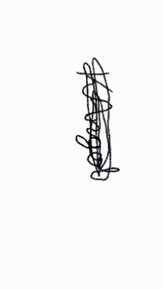

DATE  22th November 2022

## UWI ASSESSMENT REGULATIONS…| 52